Jade Pearl
COSC 320-001 Lab 01: Sorting and asymptotic analysis 2/8/2023

Lab report: [I have finished all the tasks of the lab by my own/I have problem ……It took me approximately ….hours/minutes to work on it.]

Pre-lab:
Reviewing design, implementation, and complexity of sorting algorithms from COSC 120 & COSC 220. I have written the Time complexity for each in their worst case scenarios.
- Bubble Sort
  - Worst case: O(n²)
- Selection sort
  - Worst case: O(n²)
- Insertion sort
  - Worst case: O(n²)
- Merge sort
  - Worst case: O(n log(n))
- Quick sort
  - Worst case: O(n²)
- Radix sort
  - Worst case: O(nk)

Lab 01:

Exercise 1: Implement a double-ended selection sort: starts from two elements and searches the array for the maximum and minimum values. Min value is placed in first index and max is placed in last index before finding the second smallest and second biggest elements to put in the second and second to last indexes, etc.

Created files: deSelsort.h and lab01.cpp Array: {13, 5, 2, 25, 47, 17, 8, 21}
Must print array after every pass as well as the final resulting sorted array

Source Code:
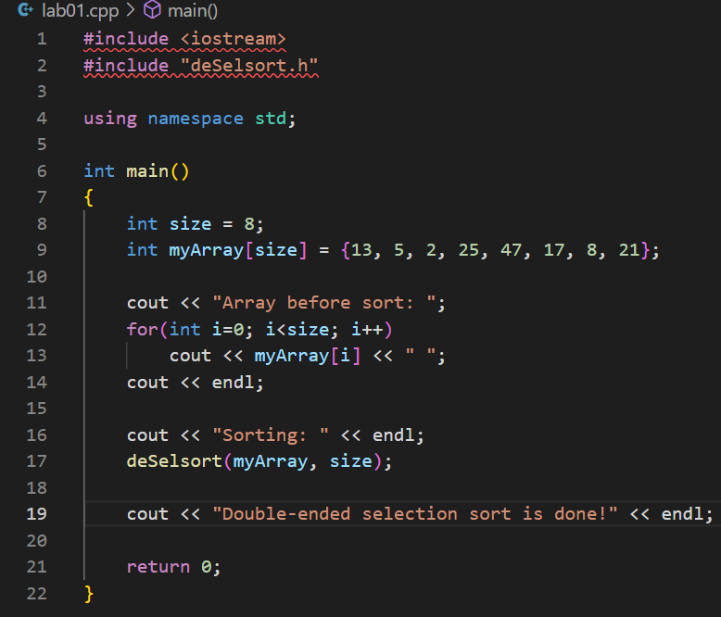

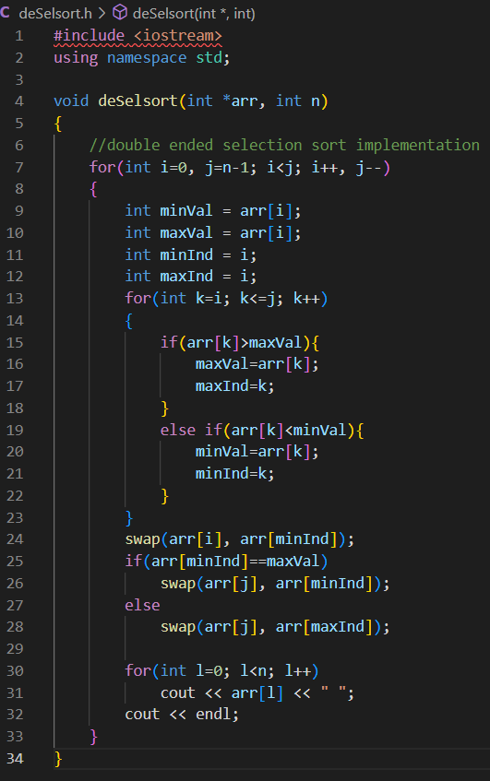

Sample Outputs:
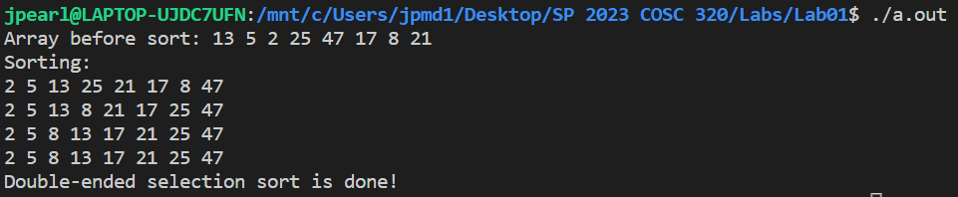

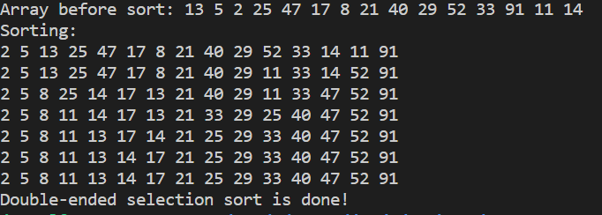

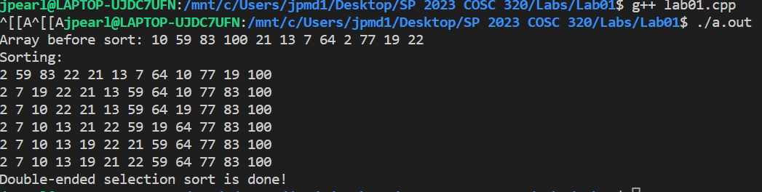

NO README file included. To compile, use linux terminal to run g++ command on lab01.cpp and then ./a.out to get the output.

Questions and Answers:
- When does your algorithm end (which means that the elements are all sorted in the array)?
The algorithm runs through all passes it takes for the array to be sorted before it lets the user know that the sort had been completed.

- What is the time complexity of the double-ended selection sort? Is it better than the selection sort?
Worst case: O(n²) is the time complexity. When it comes to smaller arrays, a double-ended selection sort does not appear to be better in terms of worst case scenario. They seem to be the same in performance and doing just as much work as one another.

